NORTH-WEST UNIVERSITY
Department of Computer Science and Information Systems

CMPG 325 — COMPUTER NETWORKS
INDIVIDUAL SEMESTER PROJECT
TECHNICAL REPORT

Leano Travel Agency (Mahikeng)
Network Design, Implementation and Verification

Project information | Details
Project ID | CMPG325-2026-059
Client ID | CLI-059
Organisation | Leano Travel Agency (Mahikeng)
Industry | Tourism
Student | [Insert student name as registered]
Student number | [Insert student number]
Submission date | 16 October 2026
Assigned address block | 192.168.32.0/24

Prepared for assessment in CMPG 325 — Computer Networks.

Report completion note
This report is a complete draft based on the project brief and configuration details visible during the project. Before submission, replace every red evidence placeholder with an actual screenshot from the final Packet Tracer file, fill in the student's details, and update the testing table to reflect only tests that were actually performed. Do not report a test as successful unless the saved evidence confirms the result.

Contents
- 1. Introduction
- 2. Requirements Analysis
- 3. Network Design
- 4. IPv4 Addressing and Subnetting
- 5. Implementation and Configuration
- 6. Security and Client Change Request
- 7. Testing and Results
- 8. Troubleshooting
- 9. Limitations and Future Improvements
- 10. Conclusion
- References
- Appendix A: Configuration Evidence
- Appendix B: Final Submission Checklist

1. Introduction

1.1 Background
Leano Travel Agency, located in Mahikeng, operates in the tourism industry and requires a computer network that supports communication between departments and access to shared resources. This project uses Cisco Packet Tracer to design, configure and test a network based on the client's assigned requirements. The assigned IPv4 address block is 192.168.32.0/24. The design divides this address block into smaller subnets and uses VLANs to separate departmental and shared-resource traffic.
The project includes Router-on-a-Stick inter-VLAN routing, a shared printer-zone change request (CR8), and a constraint requiring server-room access to be restricted to authorised IT staff. The final implementation must provide appropriate connectivity, demonstrate the assigned networking challenge, and include configuration and test evidence.

1.2 Aim
The aim is to design, implement and verify a functional, segmented computer network for Leano Travel Agency in Cisco Packet Tracer, meeting the assigned addressing, inter-VLAN routing, shared printer and server-room access requirements.

1.3 Objectives
- Design a logical topology that meets the client's network requirements.
- Subnet the assigned 192.168.32.0/24 address block for the required VLANs.
- Configure switch VLANs, access ports and a trunk connection to the router.
- Configure Router-on-a-Stick subinterfaces to provide inter-VLAN routing.
- Provide a shared printer zone that serves the two departments specified by CR8.
- Restrict access to server resources to authorised IT staff using an appropriate control.
- Test connectivity and access restrictions, document troubleshooting, and retain evidence in the GitHub portfolio.

2. Requirements Analysis

2.1 Client and scope
The assigned client is Leano Travel Agency (Mahikeng), Client ID CLI-059. The solution is specific to this client scenario and uses the address block 192.168.32.0/24. Cisco Packet Tracer is used for the network implementation and simulation.

2.2 Functional requirements
- Provide appropriate connectivity between required network devices.
- Separate departmental traffic using VLANs.
- Route permitted traffic between VLANs using Router-on-a-Stick.
- Provide shared printer connectivity for the two departments identified in CR8.
- Permit authorised IT staff to access the server resources while restricting unauthorised access.
- Demonstrate successful operation through repeatable tests.

2.3 Design constraint
The project brief states that server-room access is restricted to authorised IT staff only. The network design therefore requires a clear distinction between general departmental traffic and access to the server network. VLAN separation provides logical segmentation, but a routed access-control mechanism is required where traffic from other VLANs must be blocked.

2.4 Assigned networking challenge
The assigned challenge is Router-on-a-Stick (sub-interface inter-VLAN routing). A single physical router interface is divided into logical subinterfaces, with one subinterface serving as the default gateway for each VLAN. The switch-to-router link carries tagged traffic for the required VLANs.

2.5 Client change request CR8
CR8 requires a shared printer zone to serve two departments that previously could not print. The final implementation must demonstrate that both specified departments can reach the shared printer. The report must name the two departments from the final client design and include evidence of each test. A successful ping demonstrates IP reachability; it does not alone prove that a print job can be completed.

3. Network Design

3.1 Logical topology
The logical topology contains a router connected to a VLAN-capable switch. End devices are connected to switch access ports assigned to their respective VLANs. The server is located in the IT/server subnet, while the shared printer is placed in a dedicated printer VLAN. The router performs inter-VLAN routing through subinterfaces on its physical interface.
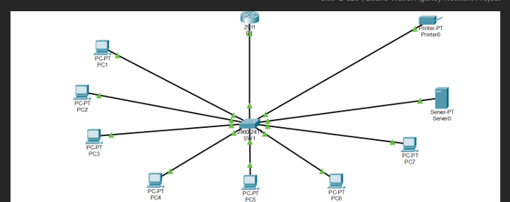
Figure 1: Logical topology of the Leano Travel Agency network.

3.2 VLAN design
VLAN ID | VLAN name | Purpose | Observed switch access ports
10 | ADMINISTRATION | Administration devices | Fa0/2–Fa0/3
20 | TRAVEL_OPERATIONS | Travel Operations devices | Fa0/4–Fa0/5
30 | FINANCE | Finance devices | Fa0/6–Fa0/7
40 | IT_SERVER | IT and server resources | Fa0/8–Fa0/9
50 | SHARED_PRINTER | Shared printer zone | Fa0/10

The SW1 command output showed VLANs 10, 20, 30, 40 and 50 in the active state. It also showed Fa0/1 operating as an 802.1Q trunk, with VLANs 10, 20, 30, 40 and 50 listed as allowed, active and forwarding. These details should be rechecked against the final saved file.
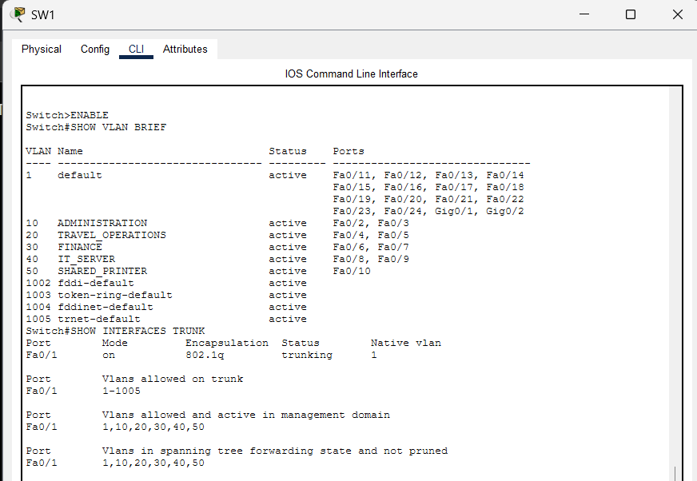
Figure 2: Verification of VLANs and 802.1Q trunk status on SW1.

3.3 Device roles
Device | Role
R1 | Provides the default gateways and routes traffic between VLANs.
SW1 | Connects end devices, assigns access ports to VLANs and trunks tagged traffic to R1.
PCs | Represent departmental and IT endpoints used for connectivity and access testing.
Server0 | Represents server resources in the IT/server subnet.
Printer0 | Represents the shared printer in the dedicated printer VLAN.

4. IPv4 Addressing and Subnetting

4.1 Assigned address block
The assigned block is 192.168.32.0/24. The design uses five /28 subnets. A /28 prefix corresponds to the subnet mask 255.255.255.240 and provides 16 total addresses per subnet: one network address, 14 usable host addresses and one broadcast address.
VLAN | Network/prefix | Subnet mask | Usable host range | Broadcast | Gateway
10 | 192.168.32.0/28 | 255.255.255.240 | 192.168.32.1–14 | 192.168.32.15 | 192.168.32.1
20 | 192.168.32.16/28 | 255.255.255.240 | 192.168.32.17–30 | 192.168.32.31 | 192.168.32.17
30 | 192.168.32.32/28 | 255.255.255.240 | 192.168.32.33–46 | 192.168.32.47 | 192.168.32.33
40 | 192.168.32.48/28 | 255.255.255.240 | 192.168.32.49–62 | 192.168.32.63 | 192.168.32.49
50 | 192.168.32.64/28 | 255.255.255.240 | 192.168.32.65–78 | 192.168.32.79 | 192.168.32.65

4.2 Example endpoint addressing
Device | IPv4 address | Mask | Default gateway | Status
PC1 | 192.168.32.2 | 255.255.255.240 | 192.168.32.1 | Verify against final file
PC2 | 192.168.32.3 | 255.255.255.240 | 192.168.32.1 | Verify against final file
PC3 | 192.168.32.18 | 255.255.255.240 | 192.168.32.17 | Verify against final file
PC4 | 192.168.32.19 | 255.255.255.240 | 192.168.32.17 | Verify against final file
PC5 | 192.168.32.34 | 255.255.255.240 | 192.168.32.33 | Verify against final file
PC6 | 192.168.32.35 | 255.255.255.240 | 192.168.32.33 | Verify against final file
PC7 | 192.168.32.50 | 255.255.255.240 | 192.168.32.49 | Verify against final file
Server0 | 192.168.32.51 | 255.255.255.240 | 192.168.32.49 | Gateway corrected and ping tested
Printer0 | 192.168.32.66 | 255.255.255.240 | 192.168.32.65 | Verify against final file

The server configuration screenshot initially showed an incorrect default gateway of 192.168.32.240. This was identified as inconsistent with VLAN 40 and corrected to 192.168.32.49. PC7 subsequently received replies from both 192.168.32.49 and Server0 at 192.168.32.51, with four packets received and zero packet loss for each test.

5. Implementation and Configuration

5.1 Switch VLAN configuration
VLANs were created on SW1 for Administration, Travel Operations, Finance, IT/server resources and the shared printer. Access ports were assigned to the corresponding VLANs. The observed port assignments are recorded in Section 3.2. The command show vlan brief was used to verify the VLAN names, active state and access-port membership.

5.2 Trunk configuration
The router-facing switch port Fa0/1 was observed to be trunking using 802.1Q encapsulation. The switch output listed VLANs 10, 20, 30, 40 and 50 as allowed, active and forwarding on the trunk. This allows tagged frames from the configured VLANs to travel between SW1 and R1.

5.3 Router-on-a-Stick configuration
R1 uses subinterfaces on GigabitEthernet0/0 to provide the default gateway for each VLAN. The router output from show ip interface brief showed the physical interface and all five subinterfaces as up/up.
Router subinterface | Gateway address | VLAN
GigabitEthernet0/0.10 | 192.168.32.1/28 | 10
GigabitEthernet0/0.20 | 192.168.32.17/28 | 20
GigabitEthernet0/0.30 | 192.168.32.33/28 | 30
GigabitEthernet0/0.40 | 192.168.32.49/28 | 40
GigabitEthernet0/0.50 | 192.168.32.65/28 | 50

The subinterfaces use VLAN-specific encapsulation and IP addressing. This configuration allows the router to route permitted traffic between the VLANs over one physical router-to-switch link.
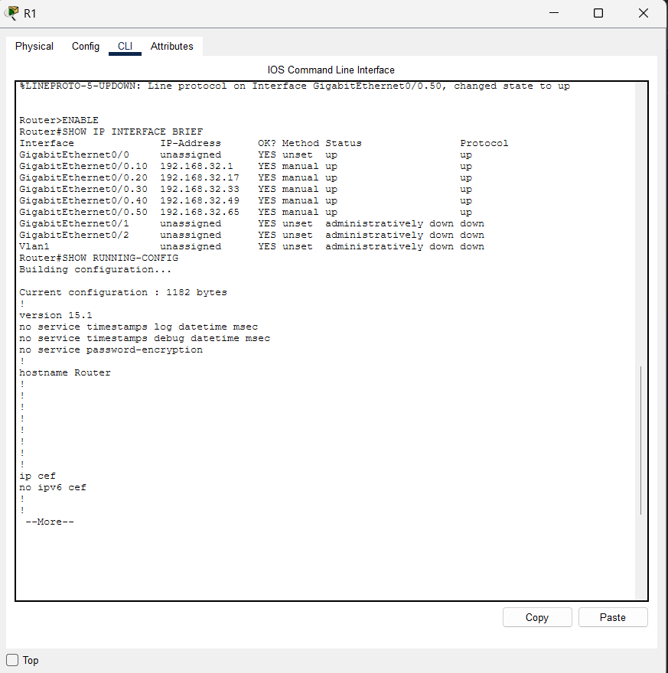
Figure 3: R1 subinterfaces showing the VLAN gateway addresses and operational status.

5.4 Server and printer configuration
Server0 was configured with IPv4 address 192.168.32.51 and subnet mask 255.255.255.240. Its default gateway was corrected to 192.168.32.49, the gateway for VLAN 40. The planned printer address is 192.168.32.66 with gateway 192.168.32.65; this must be checked against Printer0's actual IP Configuration before submission.
Final configuration evidence note: a clean screenshot showing the corrected Server0 default gateway and the Printer0 IP configuration was not included among the supplied images. Capture these two screenshots from the final Packet Tracer file before submission.

6. Security and Client Change Request

6.1 Server-room access restriction
The client constraint requires server-room access to be restricted to authorised IT staff. The server is placed in VLAN 40, the IT/server subnet. Logical segmentation separates the server subnet from the other departments, but segmentation alone does not block routed traffic. An ACL is therefore appropriate where the design requires traffic from non-IT VLANs to be denied.
A proposed ACL named SERVER_ROOM_RESTRICT permits traffic sourced from the IT/server subnet to the server subnet, denies other sources from reaching the server subnet, and permits unrelated traffic. It is intended to be applied outbound on R1's GigabitEthernet0/0.40 subinterface. The final report must only state that this control is implemented after confirming the ACL exists, the interface assignment is active, and the tests show the expected results.
The rule is subnet-based rather than user-authentication-based. It treats devices in 192.168.32.48/28 as authorised. If the requirement is to permit only specific IT endpoints, the ACL should be narrowed to the approved device addresses and any required server services should be considered explicitly. Traffic between devices on the same VLAN does not pass through the router ACL.
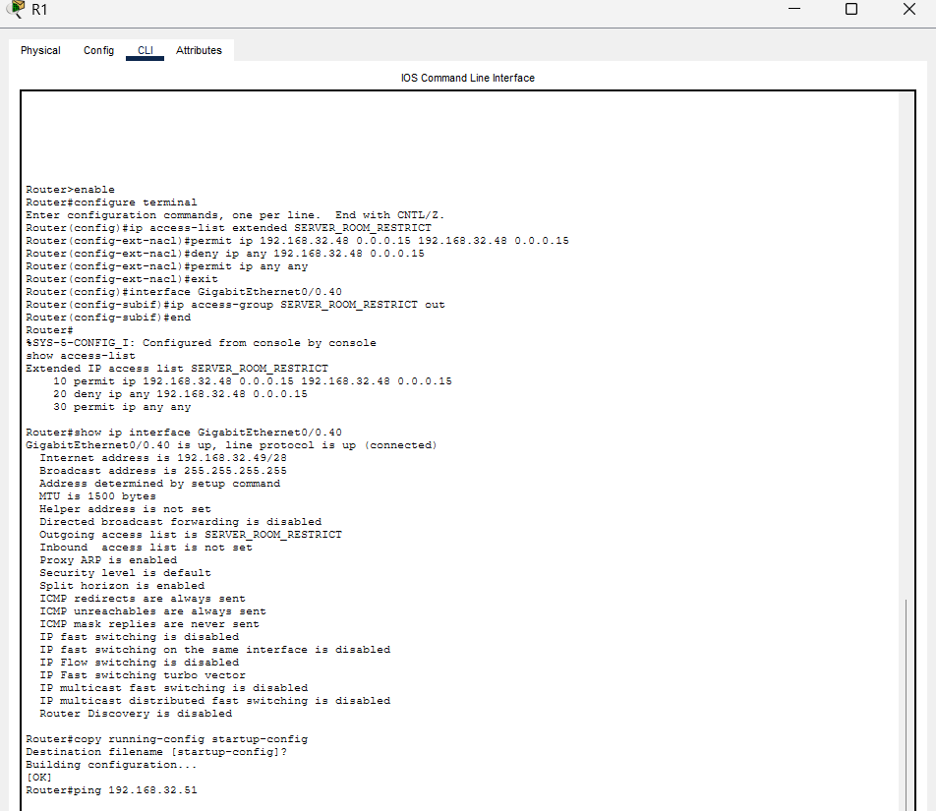
Figure 4: SERVER_ROOM_RESTRICT ACL and its application to the VLAN 40 router subinterface.

6.2 Server access test
PC7 successfully pinged the VLAN 40 gateway 192.168.32.49 and Server0 at 192.168.32.51. Each ping displayed four replies, four packets received and zero packet loss. This confirms reachability from PC7 to the gateway and server. The unauthorised-device test from PC1 must also be recorded. If the ACL is active, the expected result is that PC1 cannot reach the protected server subnet while authorised IT access remains functional.
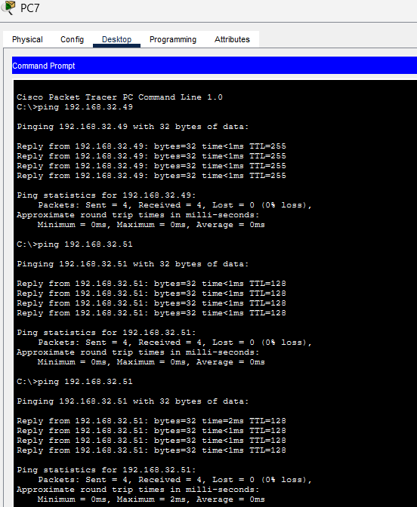
Figure 5: Authorised IT endpoint PC7 successfully reaches Server0.
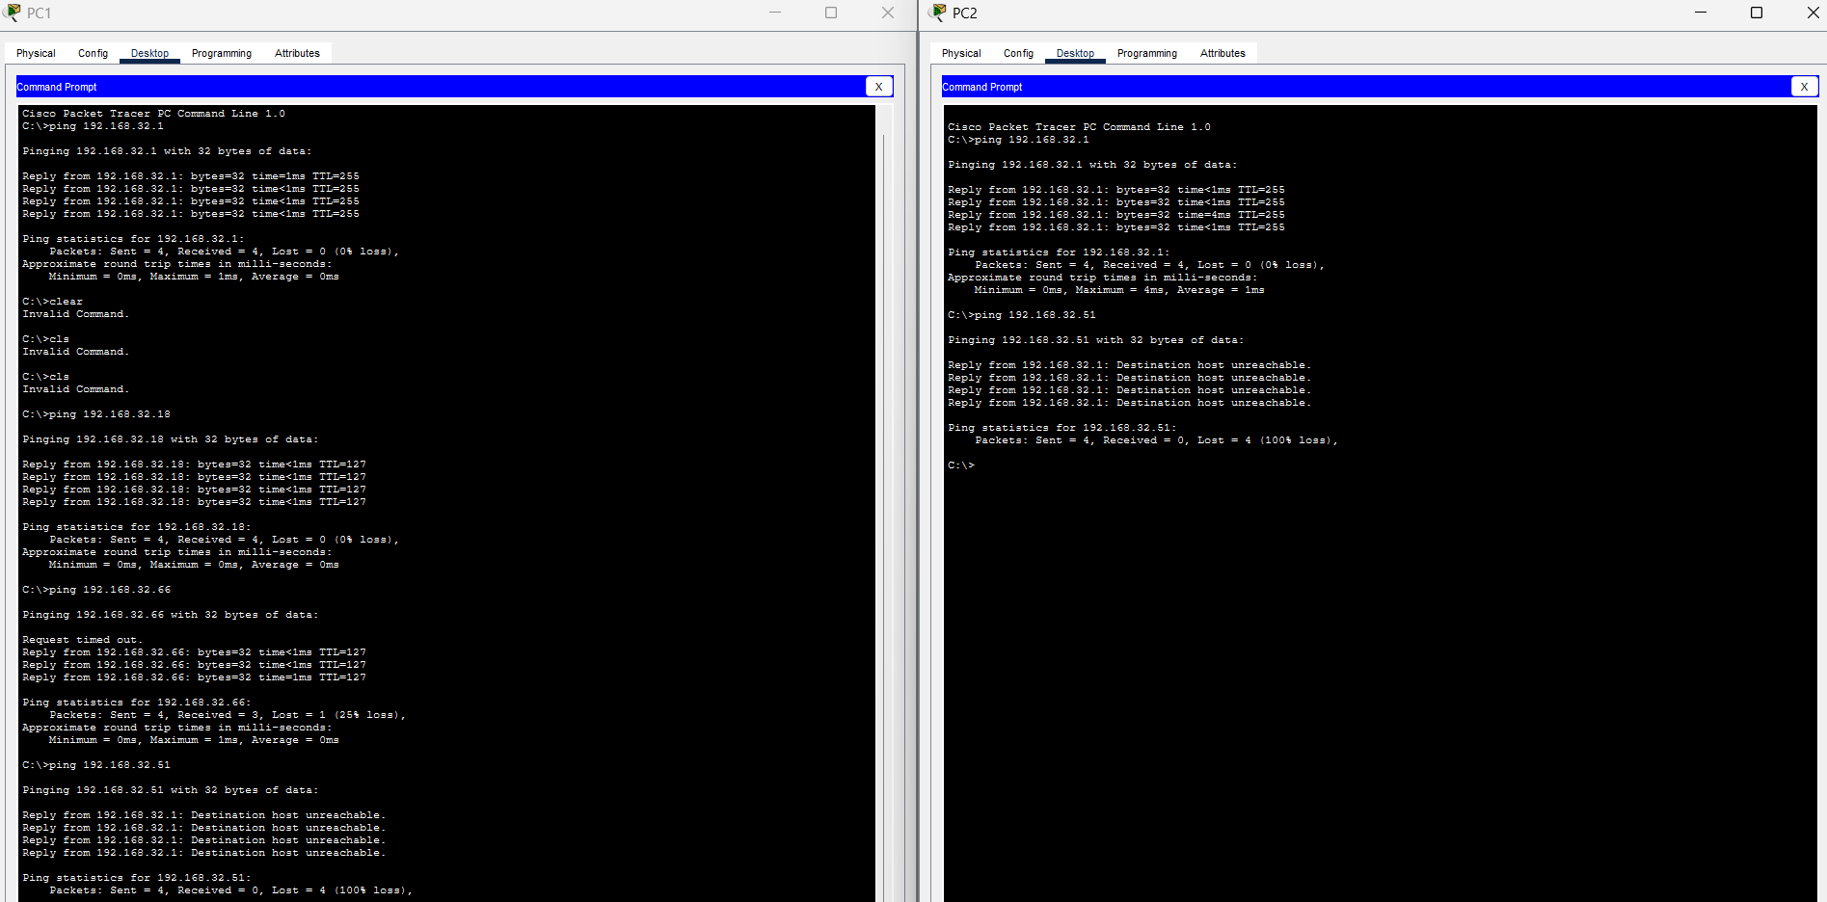
Figure 6: Unauthorised departmental endpoints PC1 and PC2 are denied access to Server0.
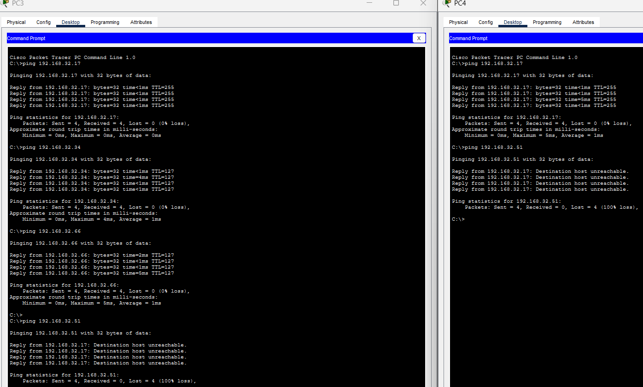
Figure 7: Unauthorised departmental endpoints PC3 and PC4 are denied access to Server0.
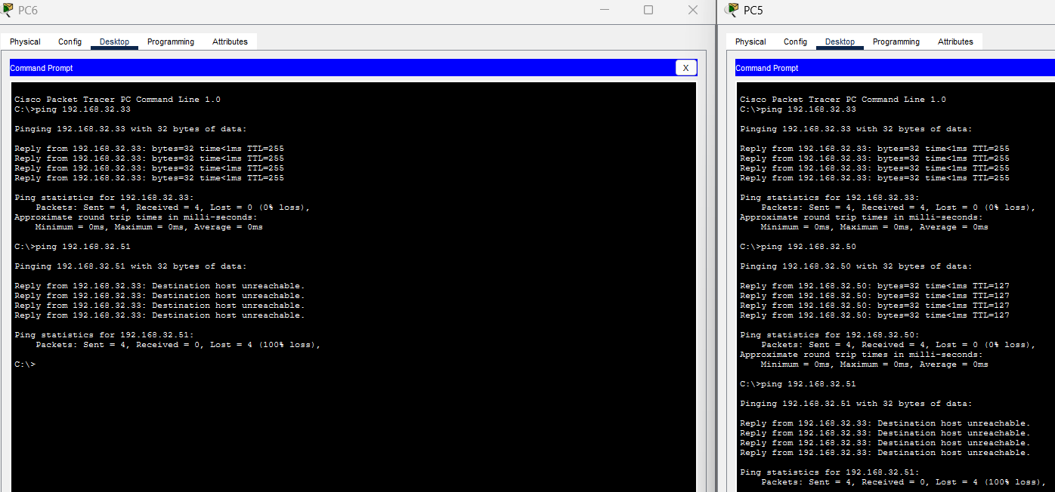
Figure 8: Unauthorised departmental endpoints PC5 and PC6 are denied access to Server0.

6.3 CR8 shared printer zone
CR8 requires a shared printer zone to serve two departments that previously could not print. Printer0 is assigned to the dedicated shared printer VLAN 50, whose planned gateway is 192.168.32.65. The planned printer address is 192.168.32.66. The final implementation must identify the two departments in the client design and show that each can reach the printer. If the brief requires actual print-job functionality, successful ping tests alone are insufficient.
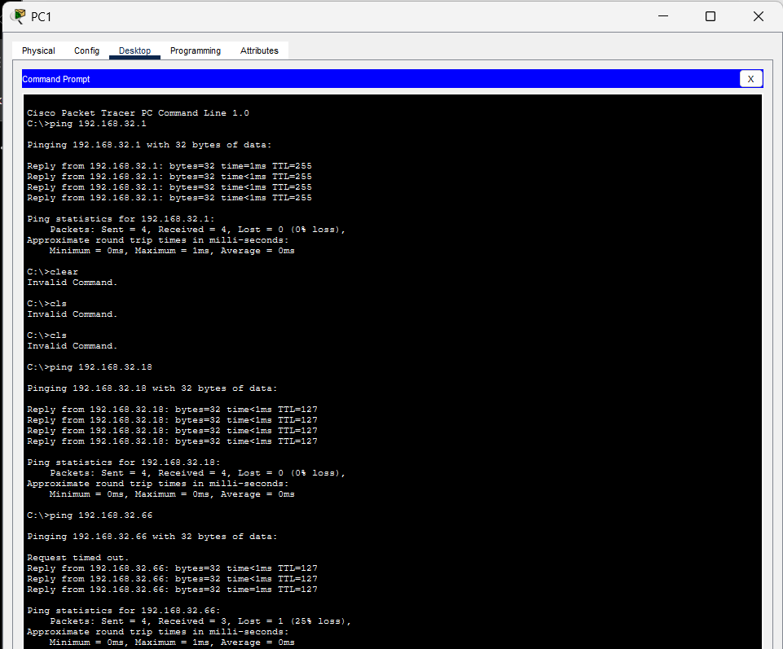
Figure 9: Connectivity test from PC1 to the shared printer at 192.168.32.66.
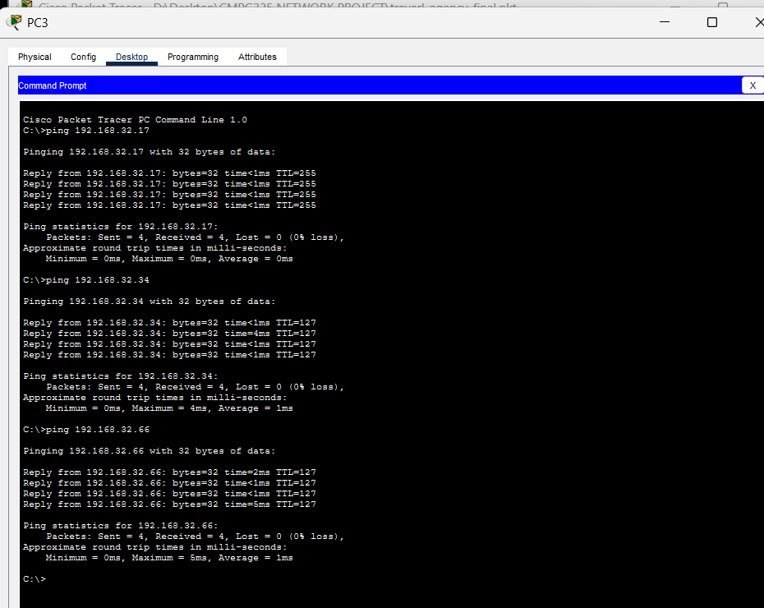
Figure 10: Connectivity test from PC3 to the shared printer at 192.168.32.66.

CR8 departments served in the final implementation: Administration (VLAN 10) and Travel Operations (VLAN 20), as represented by the PC1 and PC3 printer connectivity tests.

7. Testing and Results
Testing verifies interface status, local gateway connectivity, inter-VLAN routing, server access controls and shared printer reachability. The table below distinguishes results observed during the project from tests that must be confirmed with final evidence. Update the status column before submission.
Test ID | Test | Expected result | Observed result/status
T1 | SW1: show vlan brief | VLANs 10, 20, 30, 40 and 50 active with correct access ports | Observed: VLANs active; save screenshot
T2 | SW1: show interfaces trunk | Fa0/1 trunking; required VLANs active and forwarding | Observed: matches expected output
T3 | R1: show ip interface brief | Five subinterfaces and physical interface up/up | Observed: all five subinterfaces up/up
T4 | PC7 ping 192.168.32.49 | Replies from VLAN 40 gateway | Pass: 4 sent, 4 received, 0% loss
T5 | PC7 ping 192.168.32.51 | Replies from Server0 | Pass: 4 sent, 4 received, 0% loss
T6 | Each PC ping its own gateway | Replies from each assigned gateway | Enter final results for all PCs
T7 | Cross-VLAN ping tests | Permitted cross-VLAN traffic succeeds | Enter actual results and evidence
T8 | PC1 ping 192.168.32.51 after ACL | Unauthorised routed access blocked | Enter actual result; confirm ACL first
T9 | Authorised IT access to server | Authorised access remains functional | PC7 ping passed; retain screenshot
T10 | Printer access from CR8 department 1 | Printer reachable / print test succeeds as required | Enter actual result
T11 | Printer access from CR8 department 2 | Printer reachable / print test succeeds as required | Enter actual result
T12 | Reopen final .pkt file | File opens and reproduces working network | Complete before submission

The supplied endpoint screenshots show successful gateway checks for PC1, PC2, PC3, PC4, PC5 and PC7. The individual screenshots are included below as supporting evidence. PC6 gateway evidence was not supplied.
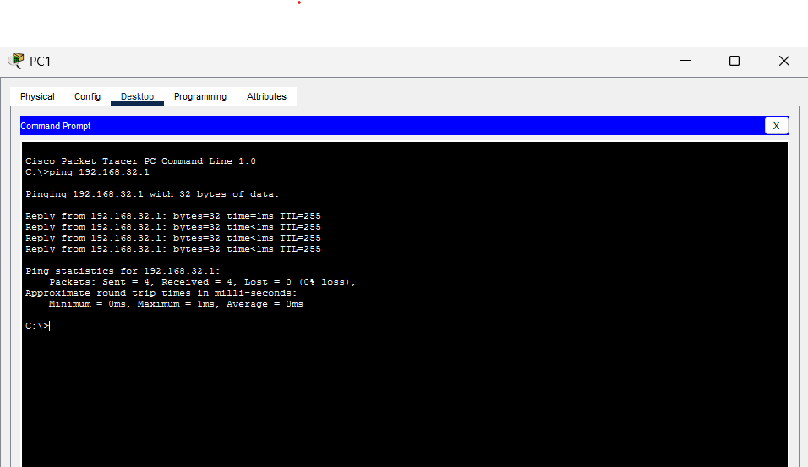  Figure 11: PC1 reaches its default gateway 192.168.32.1. | 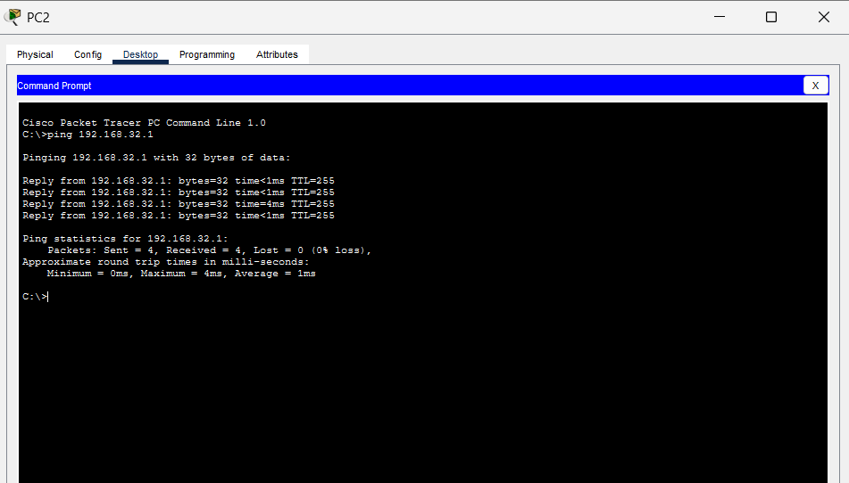  Figure 12: PC2 reaches its default gateway 192.168.32.1.
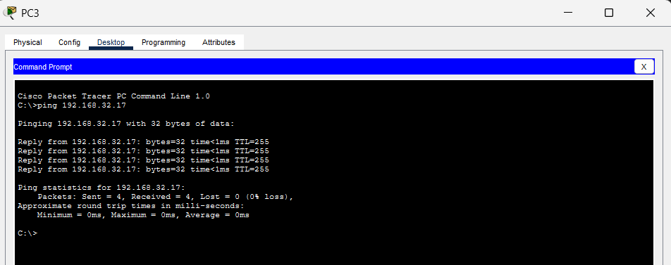  Figure 13: PC3 reaches its default gateway 192.168.32.17. | 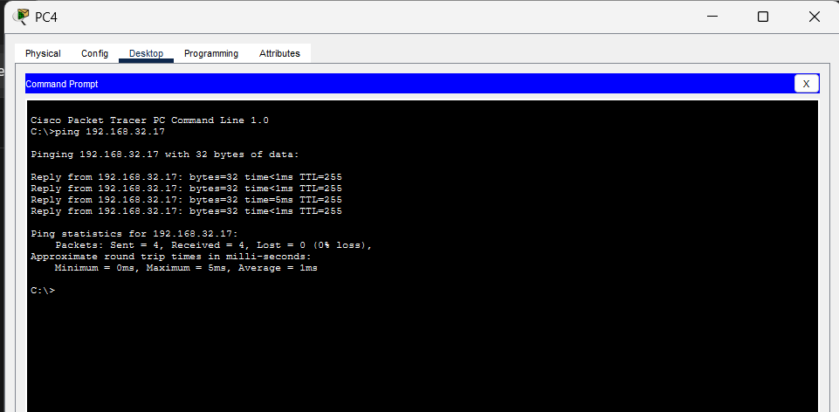  Figure 14: PC4 reaches its default gateway 192.168.32.17.
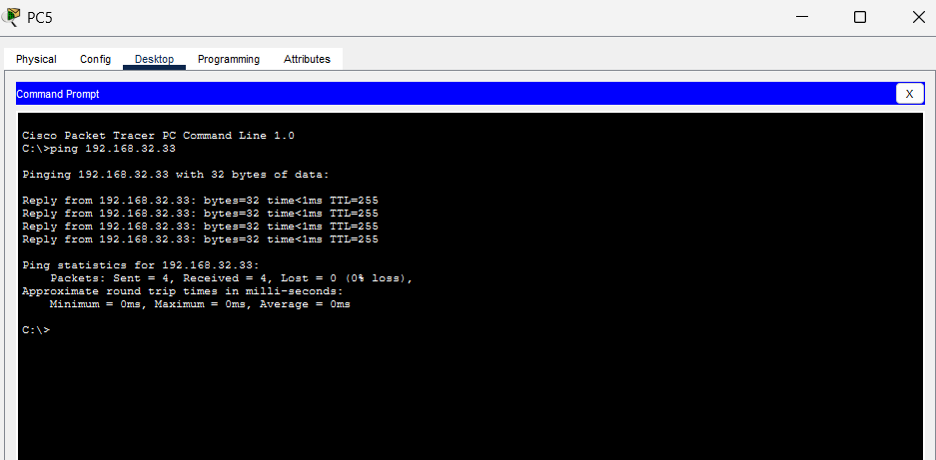  Figure 15: PC5 reaches its default gateway 192.168.32.33. | 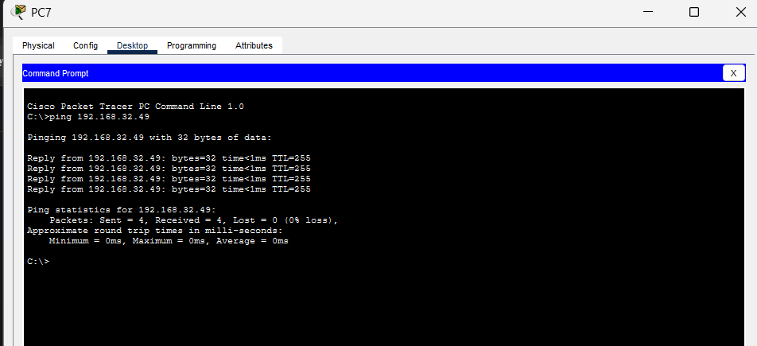  Figure 16: PC7 reaches its default gateway 192.168.32.49.
The following inter-VLAN tests provide additional evidence that traffic can be routed between departmental VLANs.
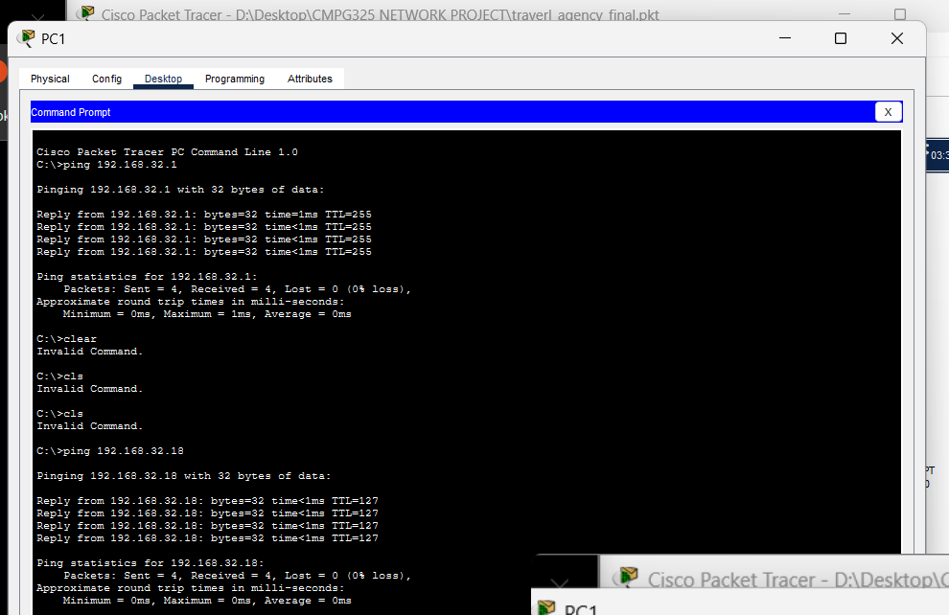
Figure 17: PC1 (Administration) reaches a host in Travel Operations.
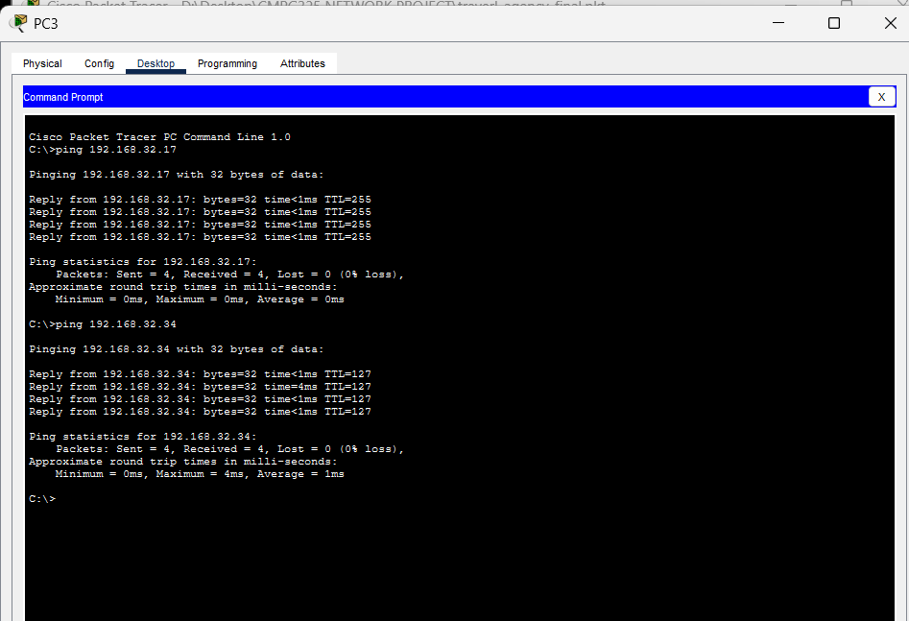
Figure 18: PC3 reaches a host in Finance.
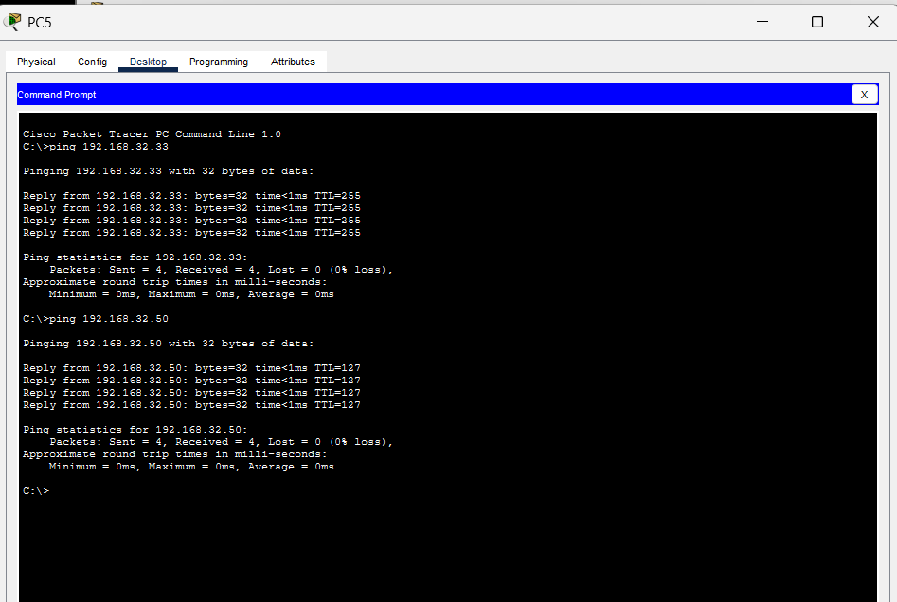
Figure 19: PC5 reaches a host in the IT/server subnet.

7.1 Evidence management
Screenshots should be captured directly from the final Packet Tracer implementation and saved with descriptive filenames. Each screenshot should show enough of the device window, command or configuration to support the claim in the report. Evidence should include the topology, VLAN and trunk output, router subinterfaces, endpoint IP configuration, connectivity tests, ACL status, and printer tests. Screenshots must not be altered to change the meaning of the results.

8. Troubleshooting

8.1 Server default gateway
During server configuration verification, Server0 was found with IP address 192.168.32.51 and subnet mask 255.255.255.240, but its default gateway was set to 192.168.32.240. That gateway did not match the VLAN 40 subnet. The correct gateway for VLAN 40 is 192.168.32.49, so the server gateway was corrected. Subsequent tests from PC7 received four replies from 192.168.32.49 and four replies from 192.168.32.51, with zero packet loss in each test.
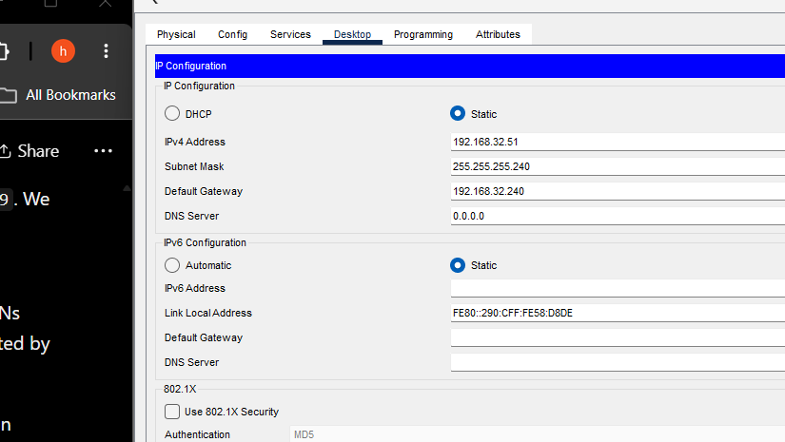
Figure 20: Earlier Server0 IP configuration showing the incorrect default gateway 192.168.32.240.

8.2 Verification approach
Troubleshooting was performed by checking the switch VLAN table, trunk status, router interface status, endpoint IP settings and ping results. This sequence helps identify whether a failure is associated with VLAN membership, the trunk, router subinterfaces, IP addressing, default gateways or an access-control rule.
Additional troubleshooting entries should be added only for issues actually encountered. For each issue, record the symptom, diagnostic command or test, cause, corrective action and result after correction.

9. Limitations and Future Improvements
- The network is a Packet Tracer simulation and does not measure the performance of a deployed physical network.
- A subnet-based ACL is not equivalent to individual user authentication. A production network may require stronger identity-aware access controls.
- Ping tests confirm IP reachability but do not verify application-level functionality or successful printing.
- The final project should retain a clear, versioned backup of the Packet Tracer file and supporting evidence.
- Any additional security, redundancy or monitoring features should be added only if they are within the approved project scope.

10. Conclusion
The project designed and implemented a segmented network for Leano Travel Agency using the assigned 192.168.32.0/24 address block. The network uses five /28 subnets and VLANs for Administration, Travel Operations, Finance, IT/server resources and the shared printer zone. Switch output confirmed that the required VLANs were active and that Fa0/1 was trunking with the required VLANs active and forwarding. Router output confirmed that the five Router-on-a-Stick subinterfaces were up/up and used the planned gateway addresses.
PC7 successfully reached the VLAN 40 gateway and Server0 after the server's default gateway was corrected to 192.168.32.49. Completion of the full client requirements must also be supported by final evidence for the server-room access restriction, the two CR8 department-to-printer tests, all required endpoint gateway checks, and reopening the final Packet Tracer file. Once these remaining results and screenshots are verified and included, the report and GitHub portfolio will provide a traceable record of the design, implementation and testing.

References
North-West University. (2026). CMPG 325 — Computer Networks: Individual Semester Project Brief, Project CMPG325-2026-059. Course-provided project brief.
Cisco Networking Academy. (n.d.). Cisco Packet Tracer [Network simulation software]. Use the exact course resource or software reference required by the lecturer if a formal citation is required.

Appendix A: Configuration Evidence
Insert the following evidence, with captions and a brief explanation of what each item proves.
- A1. Full logical topology.
- A2. SW1 show vlan brief output.
- A3. SW1 show interfaces trunk output.
- A4. R1 show ip interface brief output.
- A5. Relevant router subinterface configuration.
- A6. Server0 and Printer0 IP configuration (final screenshots still required; the earlier incorrect Server0 gateway is shown in Figure 9).
- A7. PC gateway and inter-VLAN ping results.
- A8. ACL configuration and interface assignment, if implemented.
- A9. Authorised and unauthorised server access tests.
- A10. Printer tests from both CR8 departments.

Appendix B: Final Submission Checklist
☐ Student name and student number inserted on the cover page.
☐ All red evidence placeholders replaced with actual screenshots or removed where not applicable.
☐ All test statuses updated to match actual results.
☐ CR8 department names confirmed against the approved client design.
☐ ACL implementation and access tests verified before claiming the server-room restriction is complete.
☐ Technical report exported to PDF if required by the lecturer.
☐ Final Packet Tracer file saved and reopened successfully.
☐ GitHub portfolio contains the final .pkt file, report, README and evidence.
☐ 15–20 minute video recorded with the required inset webcam view.
☐ All deliverables submitted through eFundi before the deadline.

